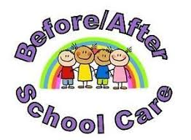

All JellyBeans Child Development Centers offer Before and After School Programs for elementary school age children for age groups 5 to 12 years old. Our school age and before and after care programs are the appropriate type of nurturing, care and gradual age-appropriate independence, needed for early to late elementary school aged children as they develop
We offer a variety of planned activities and quiet time for after school study or course work. Our centers provide before and after care as follows:

Hughesville - - T.C. Martin Elementary School
LaPlata - - Walter J. Mitchell Elementary School
Waldorf - - Arthur Middleton Elementary School
Billingsley Elementary School
Mary B. Neil Elementary School

Students enrolled at our servicing elementary schools are picked up and dropped off in front of our child care center or are driven to and from school in a designated JellyBeans Child Development Center Transportation vehicle by an authorized staff member.

